Grade:8th
Topic: William Shakespeare is famous English writer
Aims:
- To develop students' ability to communicate their opinion on and reaction to a text (Розвивати здібності учнів виражати свою думку)
- To develop students' ability to negotiate in a group and work as a team (Розвивати здатність студентів обговорювати в групі і працювати в команді)
- To develop students' ability to defend their position in a conflictive situation (Розвивати здібності учнів відстоювати свою позицію в конфліктній ситуації)
- To expand students' vocabulary on the English literature especially on William Shakespeare, his biography and creative work (Розширювати словниковий запас учнів з англійської літератури, особливо про Вільяма Шекспіра, його біографію і творчість)
- To develop Ss' capacity of speaking, reading, listening, writing (Розвивати навички говорити, читати, слухати, писати)
Aids: Power Point presentation, texts for reading, video and audio materials, a portrait of William Shakespeare, “funny faces”.
Procedure:
Greeting. Introduction.
Т. Good morning, dear children!
Ss. Good morning to you!
Warm-up activities.
T. There is no doubt that books play very important role in our life. And I’m sure, that a lot of pupils from our form like to read different kinds of books.
- Do you like reading?
- What famous writers do you know?
- What famous Ukrainian writers do you know?
- Do you like poems by Lesia Ukrainka, Taras Shevchenko?
- What famous English writers do you know?

Aim.
T. And, I’d like you look at this desk and then, maybe you tell me, what our lesson’s topic is?
Ss. William Shakespeare.
T. You are right, my dear. Today we are going to speak, read, listen and write about his biography and works because the topic of our today’s lesson is “William Shakespeare is the great English writer” it is devoted William Shakespeare's 400th Anniversary
Introducing the topic
Listening.
Pre-listening activities.
T. We have two main questions for today. The first one is “Who?”, and the second one is “What?”. Do you know what does the surname of Shakespeare mean?
to shake – трясти
a spear-спис
It means “the man shaking with the spear”. And we can say that W. Shakespeare has shaken the whole mankind with his works. So, let’s try to answer to one of our main question of the lesson “Who was William Shakespeare?”
He was not of an age and of all time.
Він – поза часом.
He is the most famous poet and playwright.
Він – найбільш відомий поет і драматург у світі.
This is William Shakespeare.
Це – Вільям Шекспір.
He wrote about love: the most victorious and eternal.
Він писав про любов: любов вічну й всепереможну.
Love… the most furious and pained.
Любов … шалену і страждальну.
Love … the most infinite and pure.
Любов … безмежну і чисту.

Vocabulary box.

Glove-maker -
Plague - чума
Terrible desease – жахлива хвороба
Big bangs- великі вибухи
Cannon - гармата
To marry — одружуватися
Childhood— дитинство
Playwright — драматург
Sonnet — сонет (вид поезії)
destroy — руйнувати

Listening. (Watching video #1)
William Shakespeare was born in 1564 in Stratford-uponAvon, in England. His father, John, was a glove-maker. His mother, Mary, was a farmer’s daughter. He had two
older sisters, two younger sisters and three younger brothers. William probably studied Latin, Greek and history, and left school when he was 14 or 15. Three years later he married Anne Hathaway. They had a daughter called Susanna and twins named Judith and Hamnet. Sometime before 1590 he left Stratford and went to London, the capital city of England. London’s first theatre opened in 1576. Shakespeare worked in London as an actor and then started writing plays too. In 1593 the plague, a terrible disease, killed thousands of people and theatres were closed. During this time William started to write poems instead of plays. His short poems are called sonnets. Shakespeare helped build a new theatre called The Globe. It opened in 1599. It was round and had space for 3000 people. At The Globe some people stood in front of the stage and others had seats. The audience shouted, clapped, booed and laughed while they watched plays. Musicians created special noises to make the plays more exciting and they had a cannon to make big bangs! No women acted in Shakespeare’s time: men and boys played all the parts. Shakespeare wrote comedies with happy endings, like A Midsummer Night’s Dream. He wrote tragedies which had sad endings, like Romeo and Juliet. His history plays are about kings and queens, like Henry V. Shakespeare wrote 38 plays, maybe more. He loved language and invented new words and expressions that we still use today.
William became rich and famous. He had houses in London and in Stratford. He
died when he was 52 on 23 April 1616. His plays and poetry were very popular 400 years ago and they are still popular today. People all over the world love his work because he wrote wonderful stories about very interesting people.

Post-listening activities.
T. You have two paper faces on your desks one of which is happy and another one is sad. Please, show me happy face if the sentence is true and the sad face if the sentence is false.
William Shakespeare was born in 1954 in Stratford-upon-Avon.
At the age of twenty he married Anne Hathaway.
A few years later he went to Oxford.
Shakespeare bought the largest house in Stratford
He began to work for the theatre company of the Lord Chamberlain’s Servants.
He played as an actor at the Globe theatre.
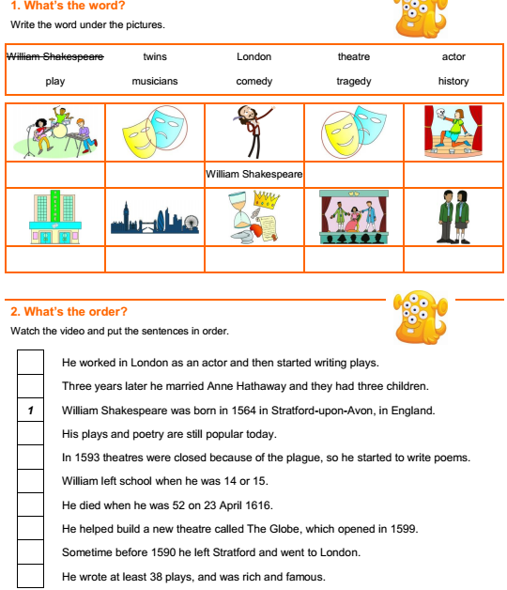
He died on April 25, 1616.

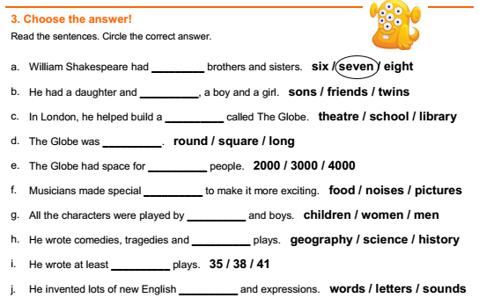
Listening (Watching video #2)
Many years ago in Verona, Italy, there were two families. “We are the Capulets.” “We are the Montagues.” These families are always fighting. The Montagues have a son, Romeo. The Capulets have a daughter, Juliet. One night the Capulets have a party and Romeo goes. He meets Juliet and they fall in love. Juliet’s cousin, Tybalt, sees Romeo and is very angry. “He’s a Montague! Get him!” “Oh Romeo, why are you a Montague?” Romeo and Juliet talk and decide to get married. They know that their families will be very angry so they go to Friar Lawrence and are married in secret. The next day, Tybalt sees Romeo. He is still angry with Romeo and wants to fight him. Romeo doesn’t want to fight but his best friend, Mercutio, does. “If you won’t fight him, I will!” Mercutio fights Tybalt. Tybalt kills Mercutio! Romeo is so upset he fights Tybalt and kills him too! The Prince of Verona is very angry and sends Romeo away. Juliet goes to Friar Lawrence for help. “Here is a special drink. You will sleep for two days. Your family will think you are dead but you will wake up. Then you and Romeo can be free together.” Friar Lawrence sends Romeo a letter to tell him the plan. But Romeo doesn’t get the message. He hears that Juliet is dead! Romeo is so upset he buys some poison and goes to see Juliet. “Now I will stay with you forever.” Too late, Juliet wakes up! She sees what happened. “Oh no! You didn’t leave any poison for me but here is your knife.” Romeo and Juliet are both dead. Friar Lawrence tells the Capulets and Montagues what happened. They are so sad they agree not to fight any more.
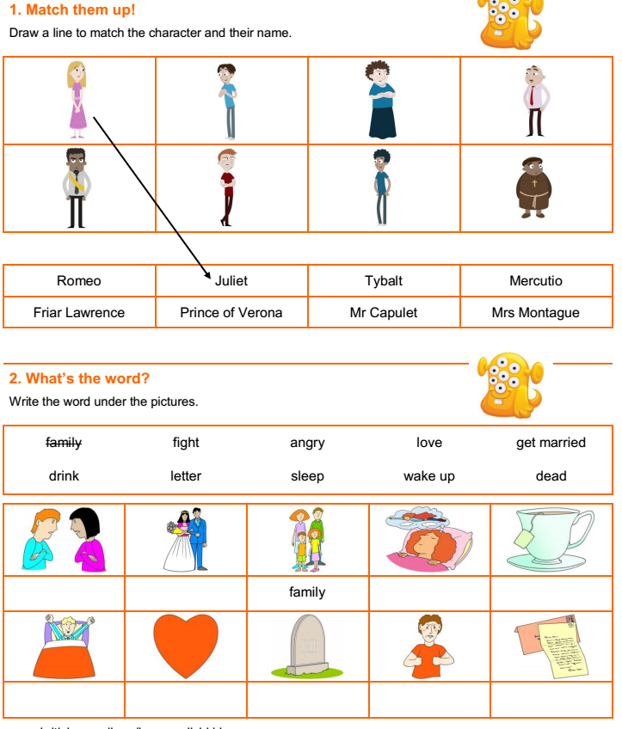

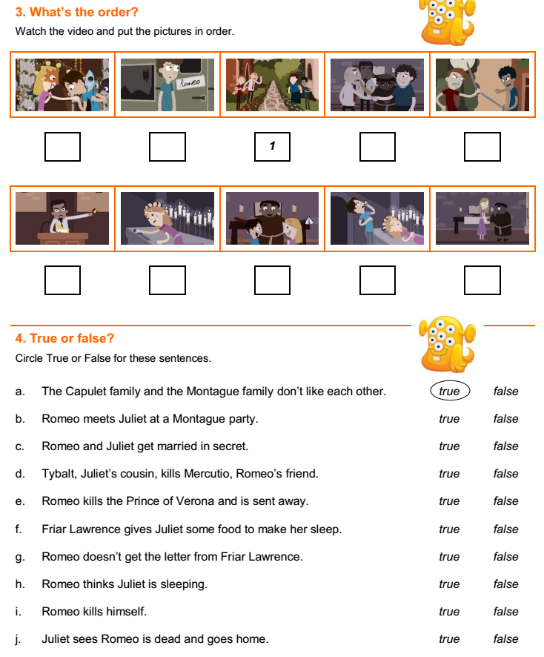
Conclusion.
T: So, my dear friends our lesson’s over and I hope you’d like to read some plays or maybe sonnets by William Shakespeare.
Hometask. Summary

Сценка
Shakespeare: (бере книгу сонетів, на фоні музики)
I got acquainted with Emily Lanye when she was 24. I was 6 years older than she. It was a dangerous woman – she changed very often. She was like a little girl. It was fashionable to create blue-eyes women but I wrote about her: dark-skinned, black-eyed and black-haired woman. I was surprised that people didn`t think that Emily was beautiful but she was not ideal. But if there were not this woman I hadn`t written my sonnets. So, I adore my Dark Lady. Кладе на столик книгу і запалює свічку
Shakespeare: Я познайомився з Емілією Лан’є, коли їй виповнилося 24. Я був на 6 років старший за неї. Це була демонічна жінка, яка постійно змінювалась і була схожа на маленьку дівчинку. Я не зважав на модну літературу, яка зображала блакитнооких красунь-блондинок. Я писав тільки про неї: смугляву, чорнооку і чорноволосу. Я обожнював мою Смагляву Красуню.
Шекспір стає на коліно і дарує троянду. Виходить Смаглява Красуня
Dark Lady: I am Emily Lanye. Although I have a blond hair, please, believe me, all these sonnets are about me. (Звертається до Шекспіра) Didn`t you see me in your dreams? Wasn`t my image before you when you started to write?..
Dark Lady: Я – Емілі Лан’є. І хоча я білявка, повірте, ці сонети про мене. Хіба ж не мене ти бачив у снах, хіба ж не мій образ стояв перед тобою, коли ночами ти брався за перо?..
130 сонет
My mistress’ eyes are nothing like the sun;
Coral is far more red than her lips’ red;
If snow be white, why then her breasts are dun;
If hairs be wires, black wires grow on her head.
I have seen roses damasked, red and white,
But no such roses see I in her cheeks;
And in some perfumes is there more delight
Than in the breath that from my mistress reeks.
I love to hear her speak, yet well I know
That music hath a far more pleasing sound.
I grant I never saw a goddess go;
My mistress when she walks treads on the ground.
And yet, by heaven, I think my love as rare
As any she belied with false compare.
Звучить пісня під російський переклад і Смаглява Красуня танцює
130 сонет
Її очей до сонця не рівняли,
Корал ніжніший за її уста,
Не білосніжні пліч овали,
Мов з дроту чорного коса густа.
Троянд багато зустрічав я всюди,
Та на її обличчі не стрічав,
І дише так вона, як дишуть люди, –
А не конвалії між диких трав.
І голосу її рівнять не треба
До музики, милішої мені,
Не знаю про ходу богинь із неба,
А кроки милої цілком земні.
І все ж вона – найкраща поміж тими,
Що славлені похвалами пустими.

