English ABC party
Звучить пісня ABC (Діти заходять в зал)
Мері Попінс (ведуча): (МР)
There are English alphabet
There are twenty six letters
All the letters are my friends
Here comes ABCDE
A is for apples
Three apples by the door,
Four apples on the floor.
My ball is big and round.
His ball is blue and brown.
C is for cat, my cat is grey.
He likes to run and he likes to play.
D is for dog and for doggy
I have a dog, his name is Bobby.
E is for English. At school we learn Russian and English too.
Do you like English? Yes, I do.
Сценка
Виходять кіт, собака та кролик
Кіт:Hello. I am a cat. I am black. This is my friend Dog
Собака: Hello I am dog. I am white and black. This is my friend Rabbit.
Kролик: I am Rabbit. I am white too.
Всі разом We glad to meet you
Йдуть
M.P : Now comes FGHIJ
F is for five and also for four. Five little dogs playing by the door,
One runs away and now they are four.
G is for girl, the girl is six.
She likes to play with little chicks.
H is for hat, Ann has a hat.
I’m a boy, I have a cap.
I is for I. I am a boy.
What have I? I have a toy.
J is for jam. Two little boys, Johnny and Sam,
Sit down to have some tea and jam.
Діти розповідають вірші
I am a Tiger,
Striped with fur.
Do not come near,
Or I might bite.
I am a monkey
I am brown
I can jump and play
In jungle
I am an Zibra
Striped with fur
I can run
Fast and slow

Йдуть

M.P : Here comes KLMNO
K is for kite, Kate has a kite.
Her kite is little, and it is white.
L is for letters, do you know them all?
Yes, I do, twenty six in all.
M is for mother. I agree she is fine.
You love your mother and I love mine.
N is for night. Good night mother, good night father,.
Good night sister, good night brother,.
O is for one. One and two is three.
Three little cats are in the tree.
Пісня «Old MacDonald had a farm» (співають всі разом)
Old MacDonald had a farm
Ee i ee i oh!
And on this farm he had a cow
Ee i ee i oh!
With a moo, moo here,
And a moo, moo there
Here a moo there a moo
Everywhere a moo, moo
Old MacDonald had a farm,
Ee i ee i oh!
Old MacDonald had a farm,
Ee i ee i oh!
And on this farm he had a pig
Ee i ee i oh!
With a oink-oink here,
And a oink-oink there
Here a oink there a oink
Everywhere a oink-oink
Old MacDonald had a farm
Ee i ee i oh!
Old MacDonald had a farm,
Ee i ee i oh!
And on this farm he had a duck
Ee i ee i oh!
With a quack-quack here,
And a quack-quack there
Here a quack-quack there a quack
Everywhere a quack-quack
Old MacDonald had a farm
Ee i ee i oh!
Old MacDonald had a farm,
Ee i ee i oh!
And on this farm he had a dog
Ee i ee i oh!
With a arf-arf here,
And a arf-arf there
Here a arf-arf there a arf
Everywhere a arf-arf
Old MacDonald had a farm
Ee i ee i oh!
Old MacDonald had a farm,
Ee i ee i oh!
And on this farm he had a cat
Ee i ee i oh!
With a meow-meow here,
And a meow-meow there
Here a meow there a meow
Everywhere a meow-meow
Old MacDonald had a farm
Ee i ee i oh!
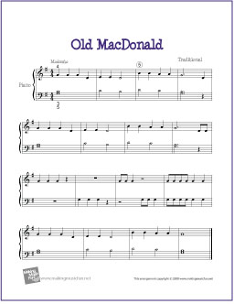

M.P: Now comes PQRST.
P is for pencils. Peter has a pencil, Peter has a pen.
He paints with his pencil and writes with his pen.
Q is for questions. How do you do, my dear sister Sue?
Very well, thank you, and how are you?
R is for roses, they are white and red.
“Give me this rose, please”, says little Fred.
S is for spring and for summer too,
When it’s warm and the sky is blue.
T is for tick and for tock.
“Tick-tock, tick – tock”, says little clock.
Сцена Monkey and elephant
Monkey: Hello I have two bananas.
Elephant: Can I have one banana ?
Monkey: Yes, you can. Неre you are.
Йдуть
M.P. and the last comes UVWXYZ
U is for under, but not for at.
“I’m under the tree”, says brother Pat.
V is in five and also in seven,
It is in twelve and in eleven.
W is for Willy and also for why.
Why do you cry Willy, why do you cry?
X is in six. Let’s count to six.
One, two, three, four, five, six.
Y is for yard, where children play.
They play in the yard every day.
Z is for zoo. Let’s go to the zoo.
I like to go to the zoo, and you?
M.P: My Family
ABCDE
This is my family
GHIJ
I love them every day
KLMNO
Mother, father, baby, oh
PQRST
Brother, sister you can see
UVWXYZ
All the people in my family
Пісня “ABC”
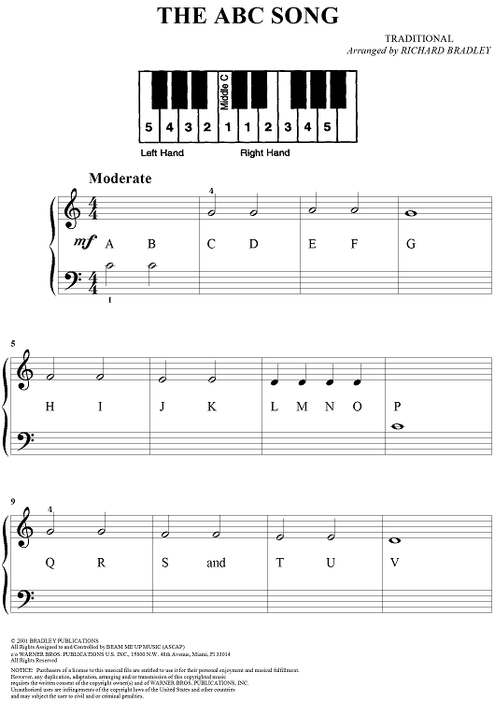
Всі виходять

